Studio9 Writeup

Exercise1: Qitao Xu, Jiangnan Liu and Zhe Wang

Exercise2:

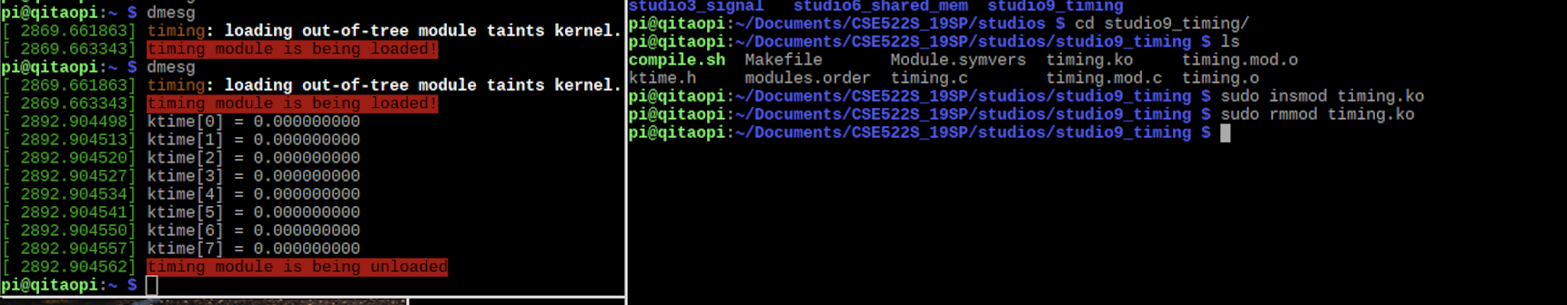

Exercise3:

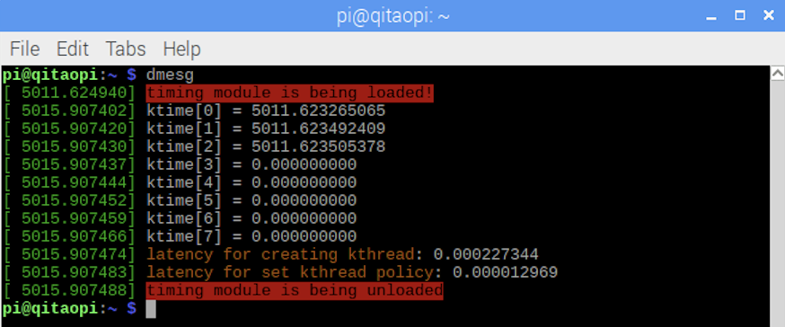

Exercise4:

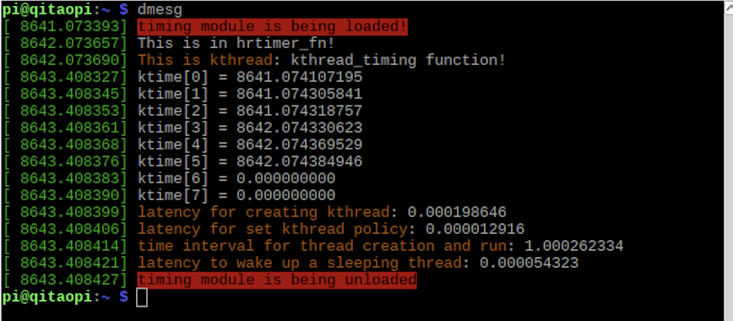

Exercise5:

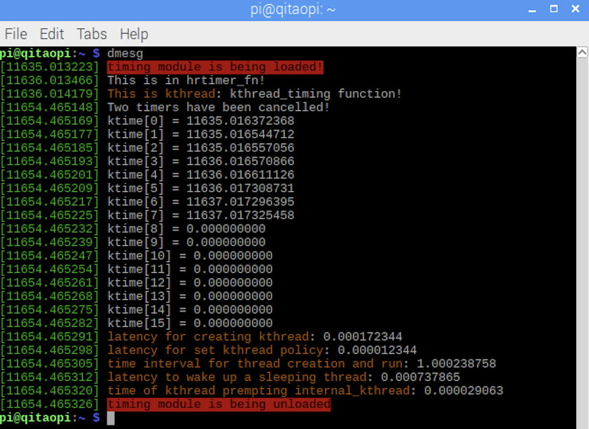

Exercise6:

